DATABASE ANALYTICS DESIGN PROJECT REPORT

GROUP NAME: Beyond The Bytes

Project Report - Database Analytics Design

1. Introduction and Client Requirements
The team acted as software consultants to propose an AI-assisted database analytics solution for a healthcare organisation. The project uses the Hospital Data for Patient Readmission Prediction dataset from Kaggle (Sharma, no date). It contains 10,000 records and 26 variables covering patient demographics, hospital activity, clinical information and resource use. Initial profiling identified 6,022 distinct patient identifiers, while 41.42% of records contain a positive value in the supplied readmission indicator.

The aim of this project is to restructure the flat dataset into a relational database that supports efficient storage, retrieval and analysis of admissions, readmissions and hospital-resource activity. Relational design can reduce duplication and improve consistency by separating data into related entities (Silberschatz, Korth and Sudarshan, 2019; Elmasri and Navathe, 2022).

2. Methodology and AI Tools
ChatGPT was used to support initial schema design, including candidate entities, relationships and validation rules. Google Gemini within Google Colab was used to generate Python/Pandas code for profiling and validation. AI outputs were reviewed before use rather than accepted automatically. diagrams.net was used for the conceptual model and dbdiagram.io for the logical model. Google Gemini was also used to support the design of the intelligent dashboard.

The proposed workflow is: Raw dataset -> AI-assisted profiling -> Python/Pandas validation and transformation -> quality classification -> relational database -> SQL analysis/reporting -> dashboard.

3. Database Design
The source CSV combines patient, encounter, hospital, ward, doctor, diagnosis and capacity information. Encounter is the central entity because each source row represents one hospital activity record. As no dependable encounter identifier is supplied, a generated EncounterID is used and a RawRowID preserves traceability to the unchanged staging record. Patient, Hospital, Ward, Doctor, Specialty, Diagnosis and ReferralDepartment are separated to reduce duplication. EncounterDoctor and EncounterDiagnosis support many-to-many relationships, while WardCapacitySnapshot stores time-varying bed information.

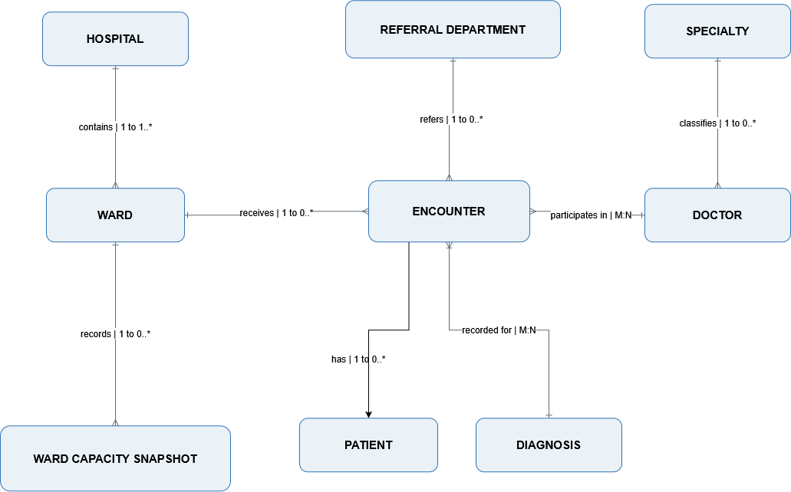
Figure 1. Conceptual ERD for the proposed hospital readmission analytics database (created using diagrams.net).

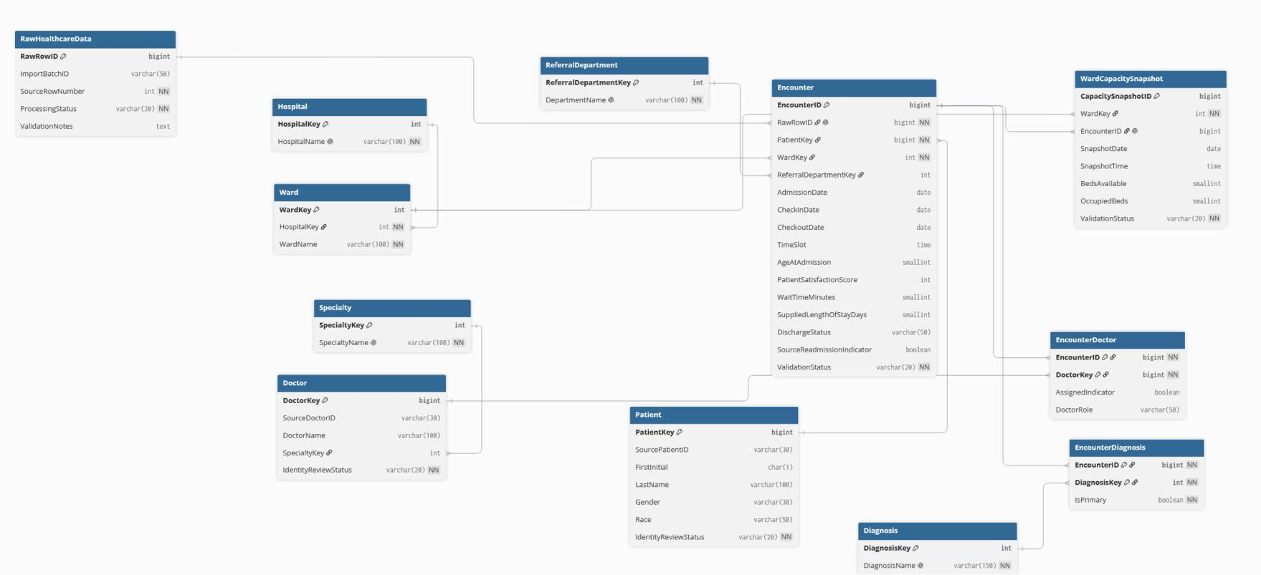
Figure 2. Logical ERD showing the proposed entities, attributes, keys and relationships (created using dbdiagram.io).

The validated relational layer is designed to Third Normal Form. Atomic values support 1NF while bridge-table attributes depend on their complete composite keys for 2NF and hospital, ward, specialty, referral-department and diagnosis descriptions are held in dedicated entities for 3NF.
This structure reduces data redundancy and the risk of insertion, update and deletion anomalies.
RawHealthcareData remains deliberately denormalised as the staging and audit layer (Silberschatz, Korth and Sudarshan, 2019; Elmasri and Navathe, 2022). Detailed field mapping is provided in Appendix B. Each validated Encounter links to a Patient, Ward and RawHealthcareData row; Hospital contains Wards; and encounters can link to Doctors and Diagnoses through bridge tables.

4. Data Profiling, Cleaning and Transformation
Gemini-assisted profiling confirmed 26 variables, no missing values and no exact duplicate rows. However, 2,754 repeated patient IDs had conflicting demographic information (Appendix E). Further checks found that 47.5% of records had a patient_checkout_date earlier than patient_checkin_date (Appendix F), while 50.58% had a recorded patient_length_of_stay inconsistent with the corresponding dates (Appendix G).

These findings support the use of generated internal keys and explicit validation rules. Records are proposed to be classified as VALID, WARNING or QUARANTINED rather than silently corrected. VALID records pass required checks; WARNING records contain possible inconsistencies that may still be legitimate; and QUARANTINED records contain significant logical problems requiring review. Data-quality and reconciliation controls are summarised in Appendix C.

5. Proposed Build, Analysis and Dashboard
All source rows will first be retained in RawHealthcareData. Python/Pandas will then execute reviewed validation and transformation rules before eligible records are loaded into the relational database. SQL extraction can support analysis of readmission rates, length of stay, waiting times, diagnosis, ward activity and resource utilisation. Appendix I provides PostgreSQL-compatible examples for these extracts. The readmission queries report the supplied indicator descriptively; the dataset does not define a clinical readmission window.

The proposed dashboard presents key performance indicators (KPIs), such as readmission rate, average length of stay, average waiting time, bed availability and occupancy, and patient satisfaction, with filters for ward, diagnosis, specialty, referring department, patient characteristics (age, gender, and race), and reason for discharge.

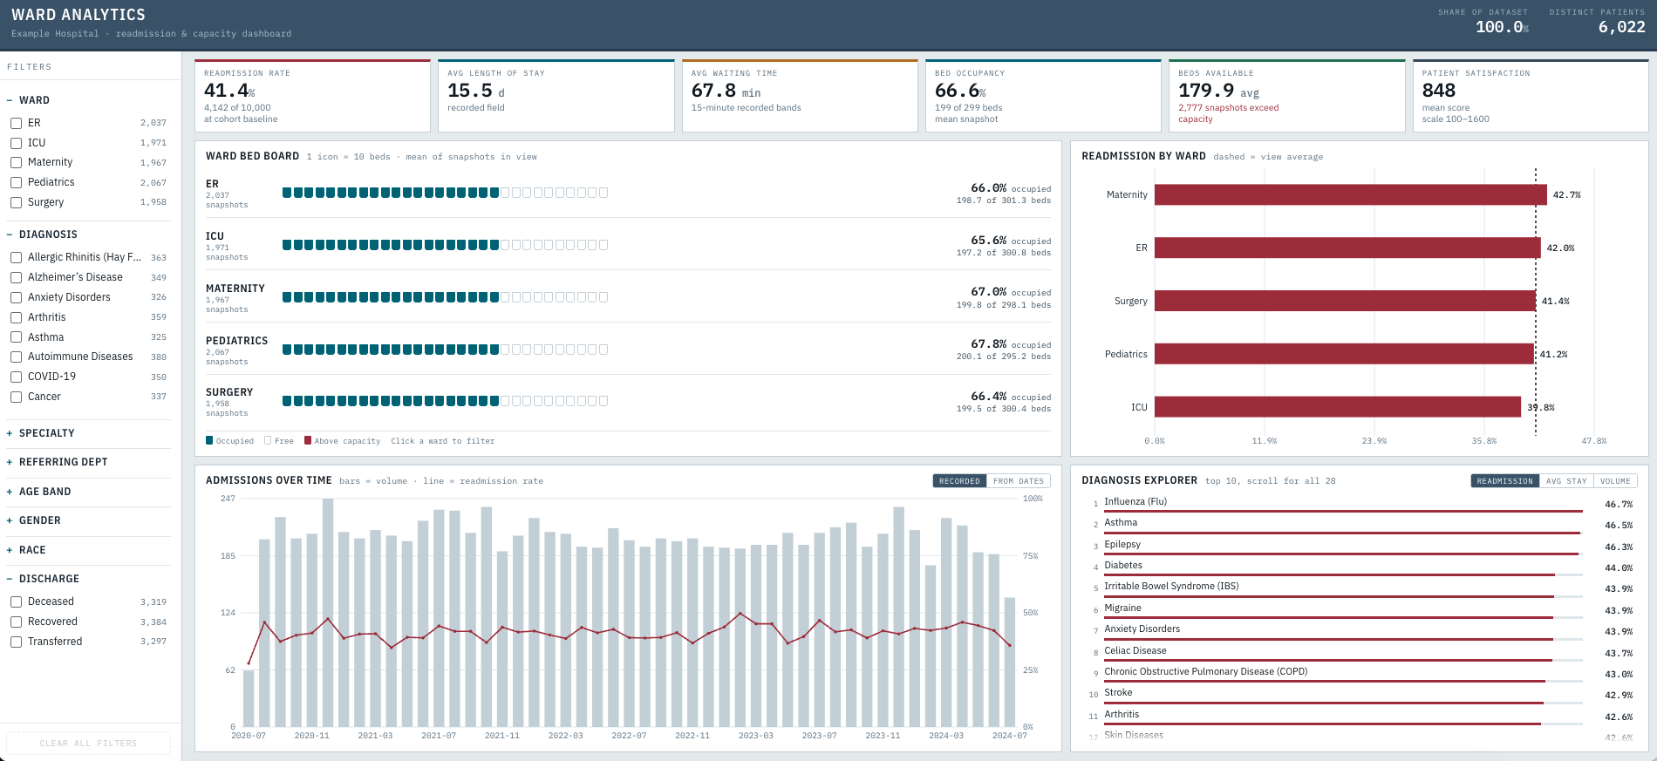
Figure 3. Proposed intelligent dashboard (created with Google Gemini)

6. Critical Evaluation of AI Tools
The integration of AI into the data management pipeline responds to the growing need for automated processes capable of handling increasingly complex data (Agarwal et al., 2024). Gemini successfully translated natural language requests into executable Pandas code, allowing for the profiling of a large dataset without manual coding. However, although AI accelerated the work, it did not replace human judgement, as the outputs obtained required testing and refinement before they could inform the final design.
Machine Learning can be highly beneficial for data integration and transformation tasks (data extraction, schema alignment, and cleaning), reducing costs and improving accuracy (Dong and Rekatsinas, 2018). Gemini helped to identify significant logical and data integrity issues, such as a patient being different ages on readmissions. Gemini made assumptions unsupported by evidence, such as proposing a stable primary key despite conflicting demographic information or suggesting resolution methods (most frequent/earliest value) that did not establish actual value correctness (Appendix H). Additionally, Gemini analysis appeared authoritative while only being based on metadata, reinforcing the need to programmatically validate AI-generated claims.
AI is also being increasingly used for the visualisation of research outputs through the creation of intelligent dashboards, which automatically generate, enhance, and assess visual data representations (Wu et al., 2022). Gemini also succeeded at translating the desired measures for visualisation into a professional dashboard design; however, iterative prompting and refinement were required to align the dashboard with the team’s analytical requirements.
Overall, the use of ChatGPT and Gemini demonstrated that AI can substantially accelerate database design, data profiling, transformation and visualisation, but cannot replace human judgement. Due to AI’s tendency to make unverified assumptions and to rely on surface-level metadata, strict human validation remains indispensable to ensure true data integrity and accuracy throughout the data management pipeline.

Reference List

Agarwal, A. et al. (2024) ‘Optimizing data management pipelines with Artificial Intelligence: Challenges and opportunities’, Journal of Computational Analysis and Applications, 33(8), pp. 2615-2636. Available at: https://eudoxuspress.com/index.php/pub/article/view/2177/1448 (Accessed: 28 August 2026).

Dong, X. L. and Rekatsinas, T. (2018) ‘Data integration and Machine Learning: A natural synergy’, Proceedings of the 2018 International Conference on Management of Data (SIGMOD '18), Houston, United States of America, 10-15 June. New York: Association for Computing Machinery. 6 pp. Available at: https://doi.org/10.1145/3183713.3197387

Elmasri, R. and Navathe, S. B. (2022) Fundamentals of database systems. 7th edn. Harlow: Pearson Education Limited.

Sharma, P. (no date) Hospital data for patient readmission prediction: Predicting patient readmissions using hospital visit data. Kaggle. Available at:
https://www.kaggle.com/datasets/prasad22234/hospital-data-for-patient-readmission-prediction
(Accessed: 22 August 2026).

Silberschatz, A., Korth, H. F. and Sudarshan, S. (2019) Database system concepts. 7th edn. New York: McGraw-Hill Education.

Wu, A. et al. (2022) ‘AI4VIS: Survey on Artificial Intelligence approaches for data visualization’, IEEE Transactions on Visualization and Computer Graphics, 28(12), pp. 5049-5070. Available at: https://doi.org/10.1109/TVCG.2021.3099002

Appendices

Appendix A - Proposed Database Data Dictionary
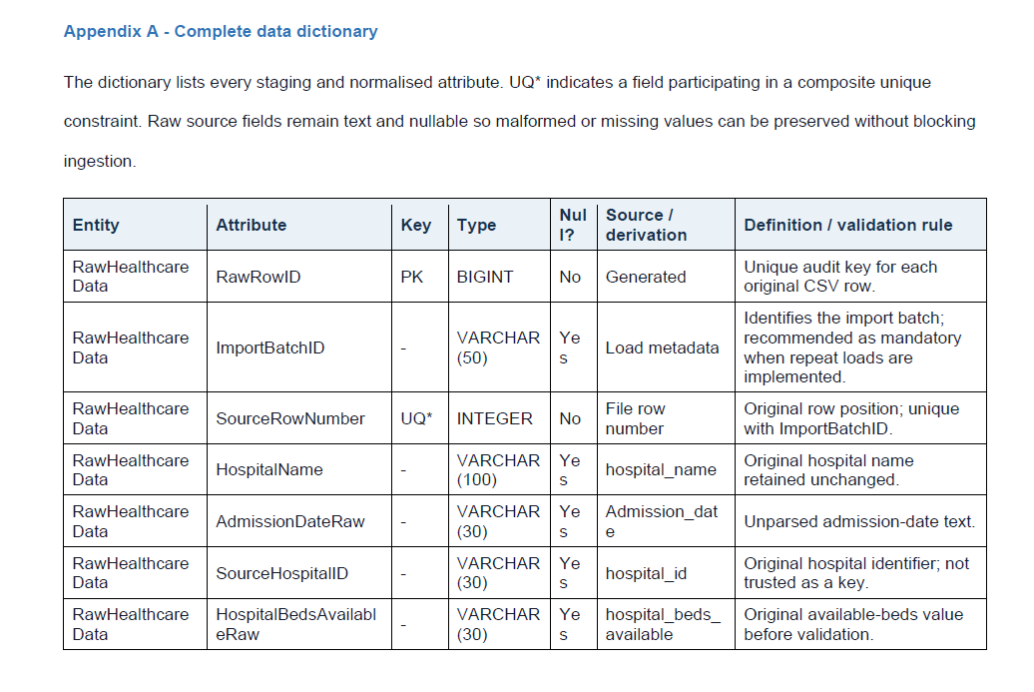

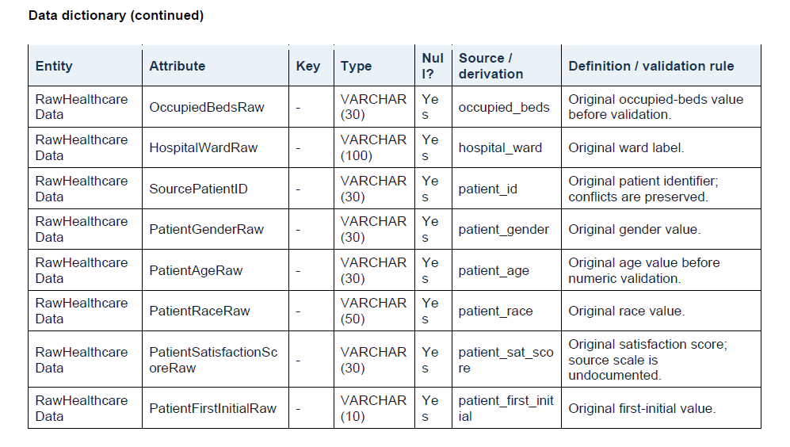
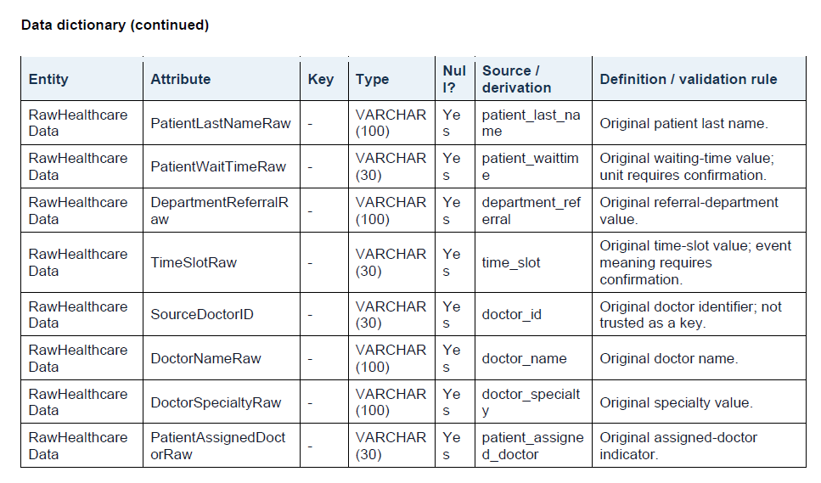
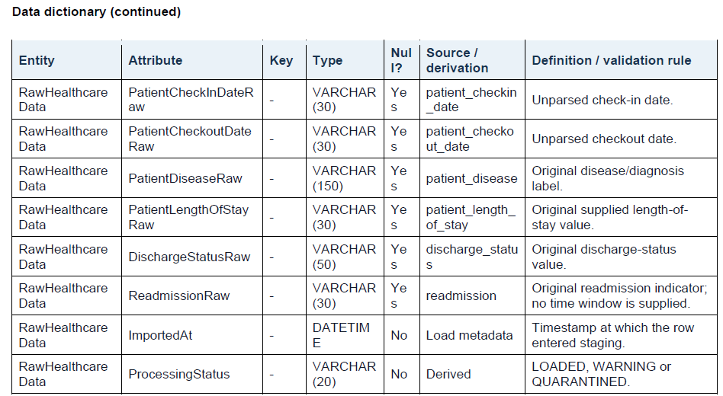
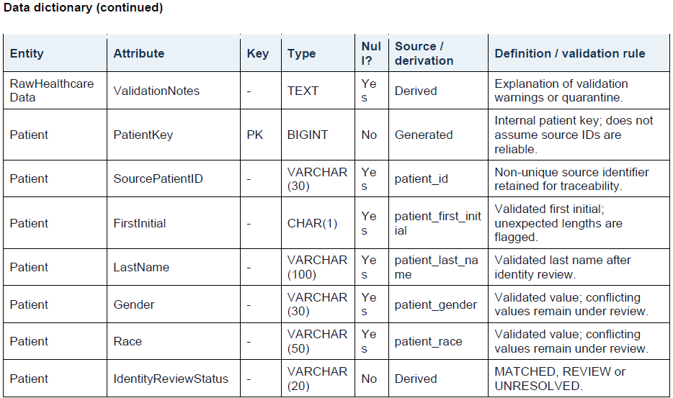
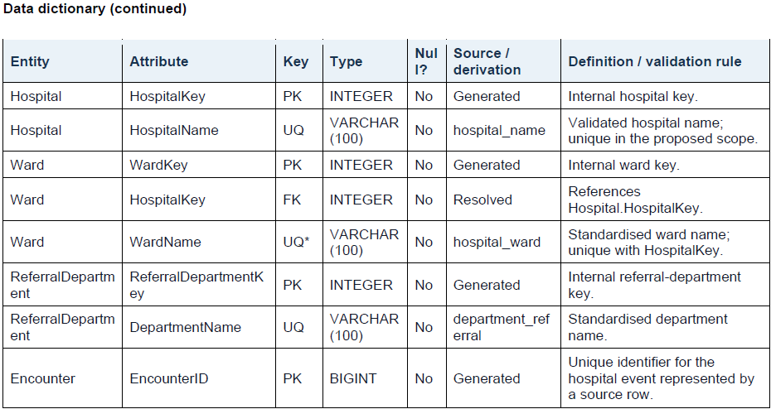
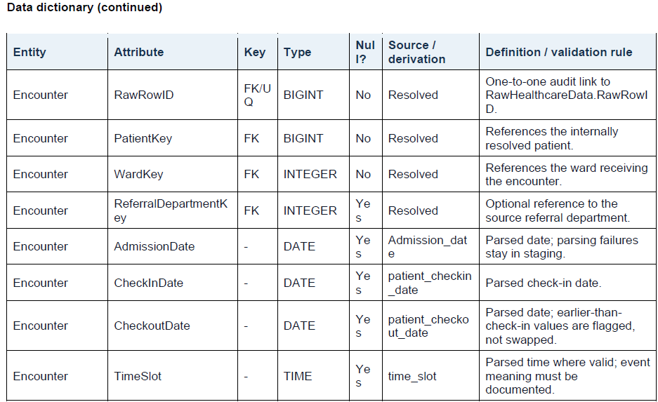
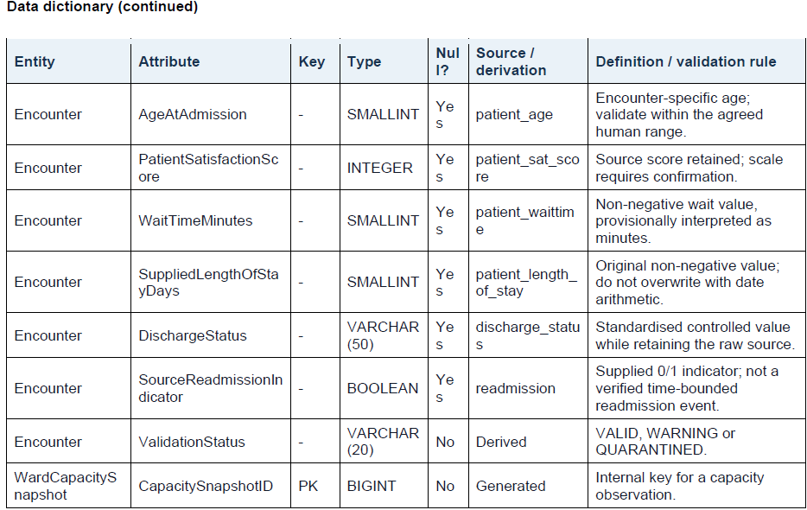
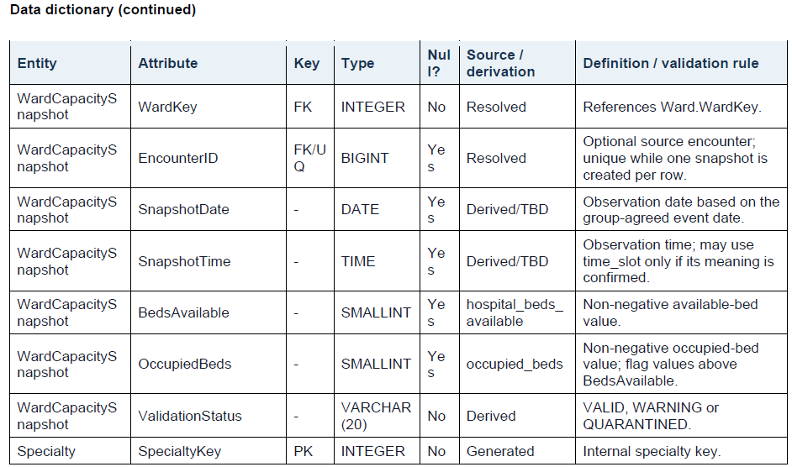
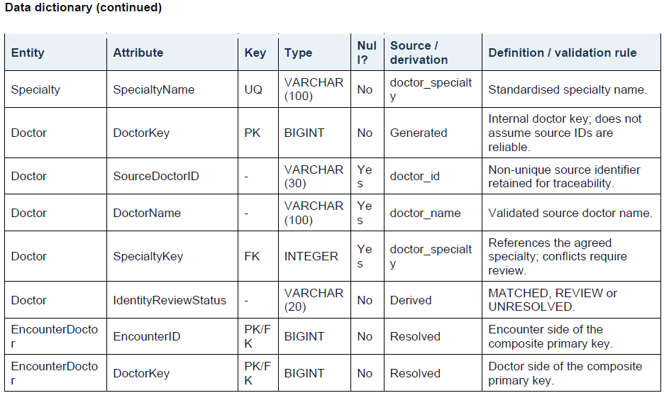

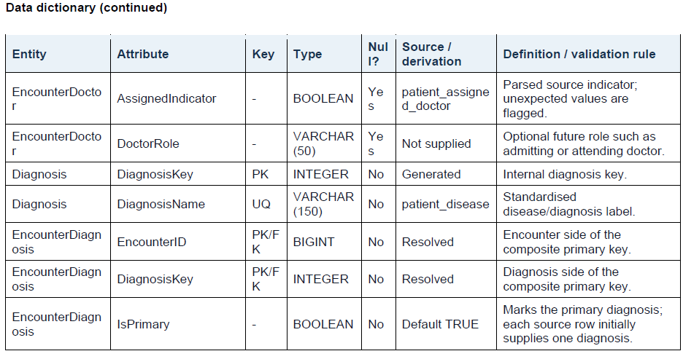

Appendix B - Source-to-Target Mapping
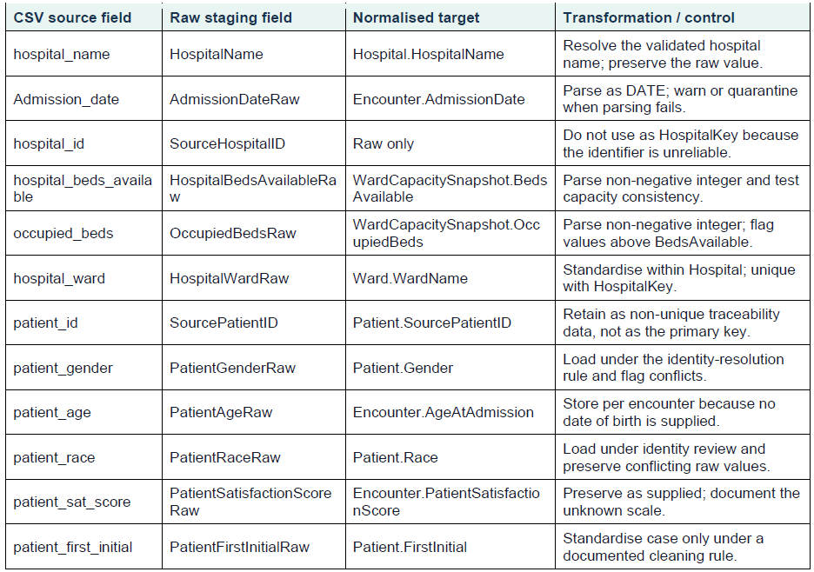

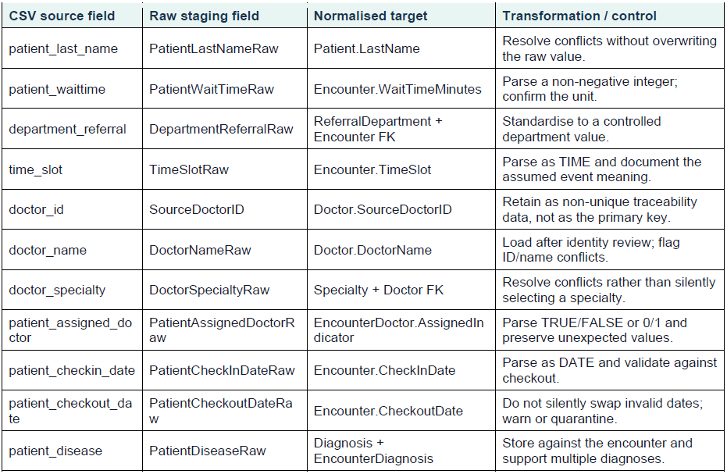
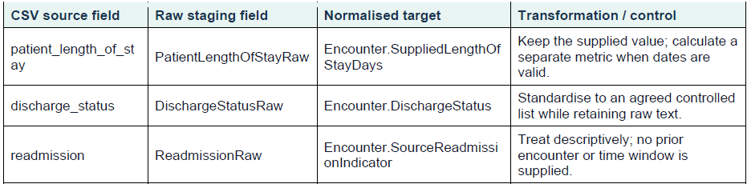

Appendix C - Data-Quality and Reconciliation Controls
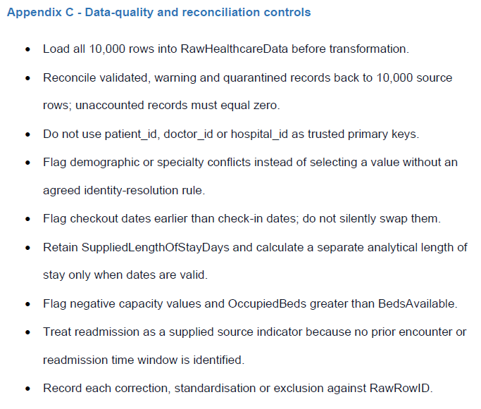

Appendix D - Concise AI-Use Evidence
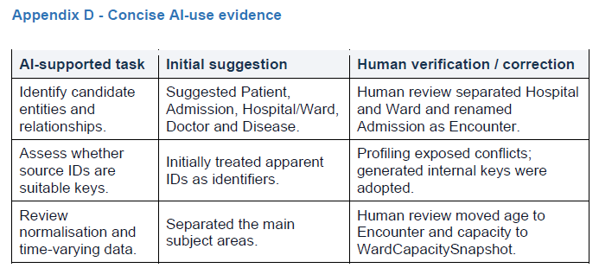
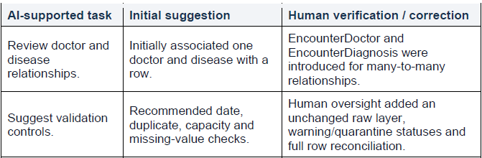

Appendix E - Identification of Conflicting Demographic Information for Repeated Patient IDs
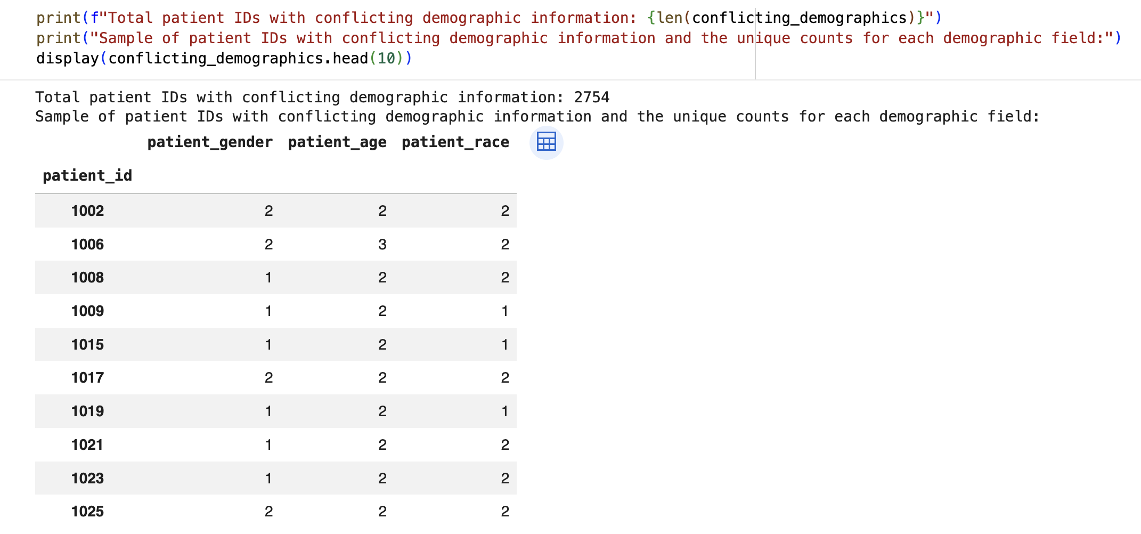

Appendix F - Identification of Logically Inconsistent Patient Check-In and Check-Out Dates
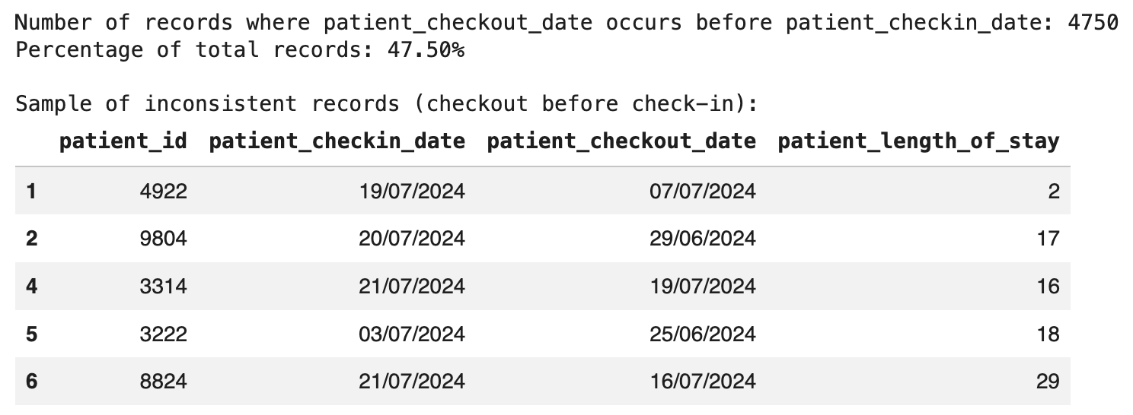

Appendix G - Validation of Recorded Patient Length of Stay Against Admission Dates
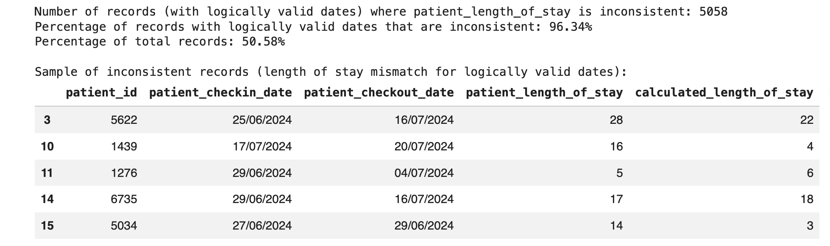

Appendix H - Example of AI Recommendation Requiring Human Review
Example retained from the project evidence showing an AI-generated recommendation that required human verification before it could inform the final database design.
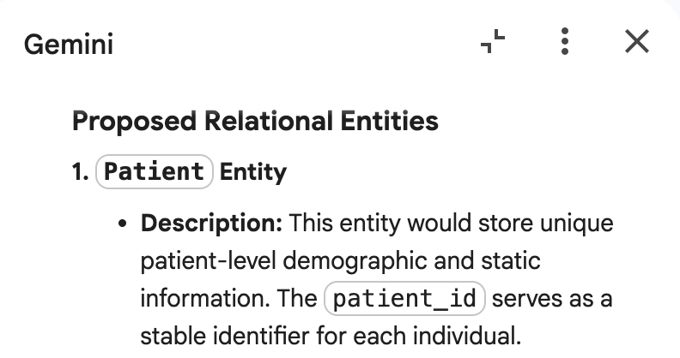

Appendix I - SQL Extraction Evidence
The following PostgreSQL-compatible SELECT statements demonstrate how the logical schema can supply the proposed dashboard measures. They use the entity and attribute names shown in Figure 2. dbdiagram.io was used to document the ERD and DBML structure; the queries should be executed in PostgreSQL or a compatible SQL client to capture result-set evidence. If another database platform is selected, Boolean and date syntax may require minor adaptation.
Interpretation note: SourceReadmissionIndicator is a supplied descriptive field. It is not a clinically validated 30-day readmission measure because the source does not define a time window or reliably link a positive value to a prior encounter.

Executed source-layer evidence
The following Google Colab result was supplied as project-team execution evidence against the original flat HealthcareData table. The query uses pandas.read_sql_query to group source rows by hospital_ward and calculate the percentage marked by the supplied readmission field.
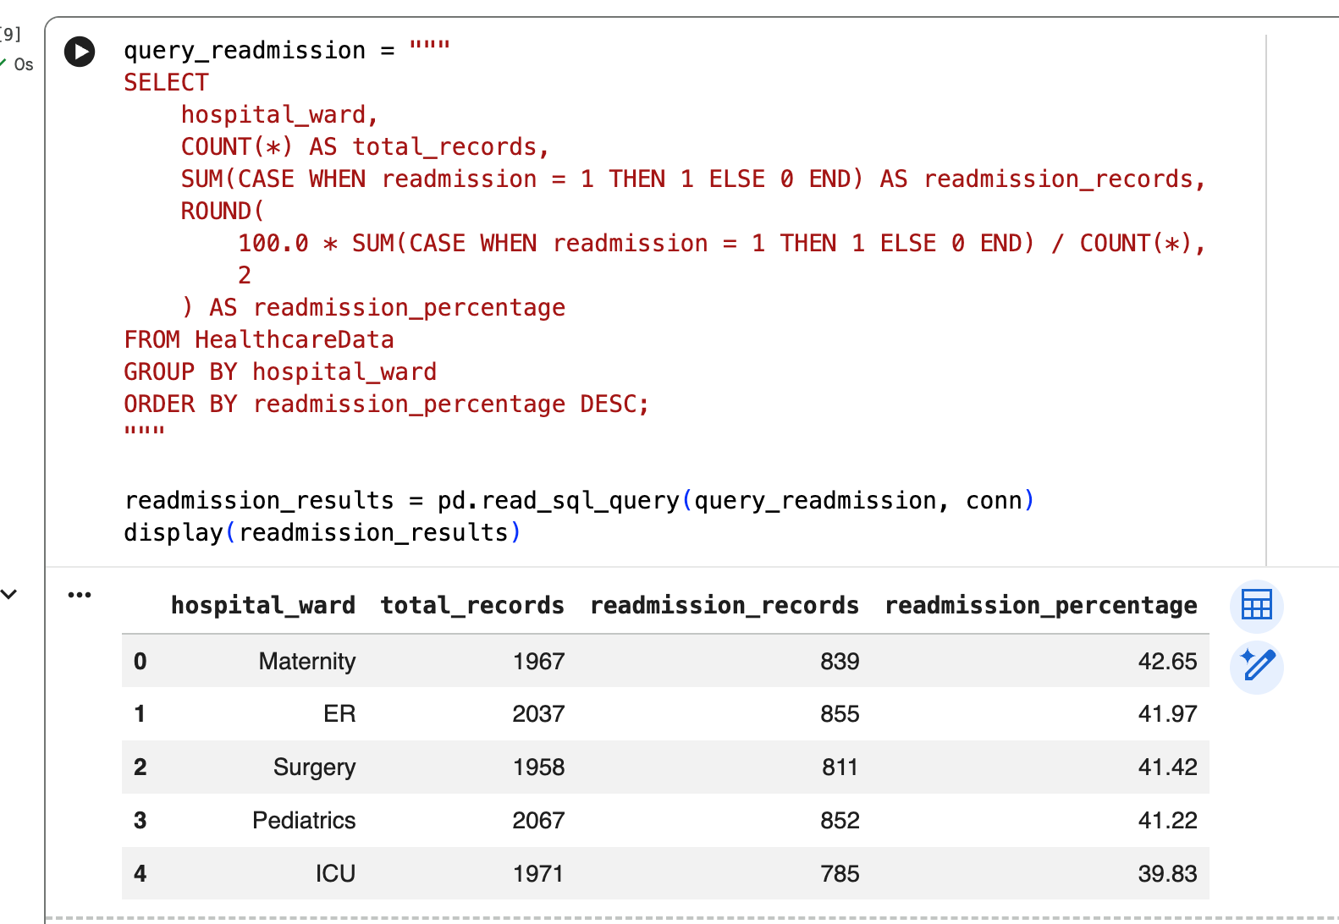
Figure I1. Executed source-layer SQL query and result set for the supplied readmission indicator by hospital ward in Google Colab.
Reconciliation: The displayed ward totals sum to 10,000 source rows and the readmission counts sum to 4,142, giving 41.42% overall. This supports the dashboard's source-layer figure. The normalised queries below demonstrate the intended post-transformation schema and may return different totals where records classified as QUARANTINED are excluded.

Query 1 - Overall source readmission indicator
Counts all encounter rows and reports the percentage marked as a readmission in the source data.
SELECT
COUNT(*) AS source_encounter_rows,
SUM(CASE
WHEN e."SourceReadmissionIndicator" = TRUE THEN 1
ELSE 0
END) AS rows_marked_readmission,
ROUND(
100.0 * SUM(CASE
WHEN e."SourceReadmissionIndicator" = TRUE THEN 1
ELSE 0
END) / NULLIF(COUNT(*), 0),
2
) AS source_readmission_indicator_pct
FROM "Encounter" AS e;

Query 2 - Readmission indicator by hospital and ward
Supports the ward comparison while excluding records classified as QUARANTINED.
SELECT
h."HospitalName",
w."WardName",
COUNT(*) AS eligible_encounters,
SUM(CASE
WHEN e."SourceReadmissionIndicator" = TRUE THEN 1
ELSE 0
END) AS rows_marked_readmission,
ROUND(
100.0 * SUM(CASE
WHEN e."SourceReadmissionIndicator" = TRUE THEN 1
ELSE 0
END) / NULLIF(COUNT(*), 0),
2
) AS source_readmission_indicator_pct
FROM "Encounter" AS e
JOIN "Ward" AS w
ON w."WardKey" = e."WardKey"
JOIN "Hospital" AS h
ON h."HospitalKey" = w."HospitalKey"
WHERE e."ValidationStatus" <> 'QUARANTINED'
GROUP BY h."HospitalName", w."WardName"
ORDER BY source_readmission_indicator_pct DESC;

Query 3 - Waiting time and length of stay by ward
Compares the supplied length-of-stay field with a value derived from valid check-in and check-out dates.
SELECT
w."WardName",
COUNT(*) AS eligible_encounters,
ROUND(AVG(e."WaitTimeMinutes")::numeric, 1)
AS average_wait_minutes,
ROUND(AVG(e."SuppliedLengthOfStayDays")::numeric, 1)
AS average_supplied_los_days,
ROUND(
(
AVG(e."CheckoutDate" - e."CheckInDate")
FILTER (
WHERE e."CheckInDate" IS NOT NULL
AND e."CheckoutDate" >= e."CheckInDate"
)
)::numeric,
1
) AS average_derived_los_days
FROM "Encounter" AS e
JOIN "Ward" AS w
ON w."WardKey" = e."WardKey"
WHERE e."ValidationStatus" <> 'QUARANTINED'
GROUP BY w."WardName"
ORDER BY w."WardName";

Query 4 - Ward occupancy and invalid-capacity checks
Calculates occupancy only for plausible snapshots and separately counts snapshots where occupied beds exceed available beds.
SELECT
h."HospitalName",
w."WardName",
COUNT(*) AS snapshot_rows,
ROUND(
AVG(
100.0 * s."OccupiedBeds"
/ NULLIF(s."BedsAvailable", 0)
) FILTER (
WHERE s."BedsAvailable" > 0
AND s."OccupiedBeds" BETWEEN 0 AND s."BedsAvailable"
),
1
) AS average_valid_occupancy_pct,
SUM(CASE
WHEN s."BedsAvailable" <= 0
OR s."OccupiedBeds" < 0
OR s."OccupiedBeds" > s."BedsAvailable"
THEN 1 ELSE 0
END) AS invalid_capacity_snapshots
FROM "WardCapacitySnapshot" AS s
JOIN "Ward" AS w
ON w."WardKey" = s."WardKey"
JOIN "Hospital" AS h
ON h."HospitalKey" = w."HospitalKey"
GROUP BY h."HospitalName", w."WardName"
ORDER BY h."HospitalName", w."WardName";

Query 5 - Diagnosis volume and source readmission indicator
Supports the diagnosis explorer through the many-to-many EncounterDiagnosis bridge.
SELECT
d."DiagnosisName",
COUNT(DISTINCT ed."EncounterID") AS encounter_count,
ROUND(
100.0 * COUNT(DISTINCT CASE
WHEN e."SourceReadmissionIndicator" = TRUE
THEN ed."EncounterID"
END)
/ NULLIF(COUNT(DISTINCT ed."EncounterID"), 0),
2
) AS source_readmission_indicator_pct
FROM "EncounterDiagnosis" AS ed
JOIN "Encounter" AS e
ON e."EncounterID" = ed."EncounterID"
JOIN "Diagnosis" AS d
ON d."DiagnosisKey" = ed."DiagnosisKey"
WHERE e."ValidationStatus" <> 'QUARANTINED'
GROUP BY d."DiagnosisName"
ORDER BY encounter_count DESC, d."DiagnosisName";
These queries demonstrate how the proposed normalised schema supports the extraction of readmission, waiting-time, length-of-stay, ward-capacity and diagnosis measures. The executed Google Colab example provides source-layer evidence, while the PostgreSQL queries show how equivalent analysis would be performed after implementing the normalised schema.

